MAINTENANCE REQUEST LIST FOR 20yy ROLL Page of .

City, Town, Village, Hamlet or R.M. of Date .

Administrator: Phone Number:
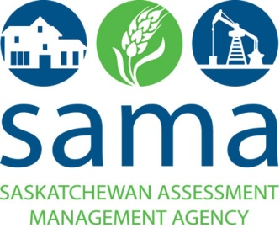

Date you would like to receive your maintenance by:

I authorize this work to be completed (Click in box for YES)
Assessment ID Number (TAXMAP OR Alternate Number) | Name of Assessed Owner  Mailing Address  Phone # | Street Address  (if different) | Legal Land Description | Reason for Inspection
Name:
Address:

Phone #:
Name:
Address:

Phone #:
Name:
Address:

Phone #:
Name:
Address:

Phone #:
Name:
Address:

Phone #:
Name:
Address:

Phone #:

If no maintenance is required for this year, mark this form as NIL and return.

Please complete and return this form by: email: weyburn.region@sama.sk.ca OR by Fax to: 306-848 -2399 OR by mail to: #314 - 110 Souris Avenue, Weyburn, SK S4H 2Z8

